

**Virgin Trains West Coast**

**Traveller Load specification**

Granby Traveller Load Design Document

Steve Forster

Technical Consultant

**August 2018**

z

Contents

1. Document Management 2

2. Document Purpose 3

2.1 In Document Scope 3

2.2 Out of Document Scope 3

3. High Level Overview 4

3.1. Process Context Diagram 4

3.2. Process Flow 5

3.2 ERD 6

3.3 Mapping 7

Granby Traveller Feed 7

TOCPlus Traveller Feed 7

Reference Data 8

Structure 8

Stored Procedures 8

# Document Management

|  |  |  |  |
| --- | --- | --- | --- |
| **Version Control** | | | |
| **Version** | **Date** | **Author(s)** | **Sections Changed** |
| 0.1 | 07/08/2018 | Steve Forster | Initial draft document |

| **Distribution List** | | |
| --- | --- | --- |
| **Organisation** | **Name** | **Role** |
| Merkle | Mark Jones | Client Lead / Project Manager |
| Merkle | Jez Cox | IBM Software SME |
| Merkle | Gary Newsome | Technical Consultant |
| Merkle | John Whittome | Business Analyst |
| Merkle | Peter Malherbe | AWS SME |
| Merkle | Mat Lynd | Development |
| Merkle | Juanjo Diaz | Technical consultant |
| Merkle | Steve Forster | Technical Solution Lead |
| Merkle | Avtar Aswell | Tester |

# Document Purpose

The purpose of this ***Granby Traveller Load Design Document*** is to define the scope of how the solution will process data for the Granby Traveller weekly feed from the pre-processing tables to the Staging tables

The list of functional requirements that will be documented in this design are covered below in the scoping section.

Each pre-processing feed process will be developed as an individual SSiS package to enable scheduling at different times depending on the file arrival details.

The load to staging will be dependent on the pre-processing for each feed to complete without error

This document should be read in conjunction with the Technical Design document and the Business Requirements documents

## 2.1 In Document Scope

The following items are in scope for this document:

* A data flow diagram showing the steps that will be covered as part of the staging process
* Logging of the number of records loaded, rejected and loaded into the processing tables
* The details of the metadata required to support the data feed loads

## 2.2 Out of Document Scope

The following items are out of scope for this document and will be covered to separate design documents:

* The SFTP to S3 bucket transfer and logging
  + This is covered as part of the pre-processing load diagram
* The design to process records through to pre-processing

# High Level Overview

## 3.1. Process Context Diagram

The trainline.com will produce a daily extract and place on their sFTP server for retrieval and processing by Virgin Trains West Coast.

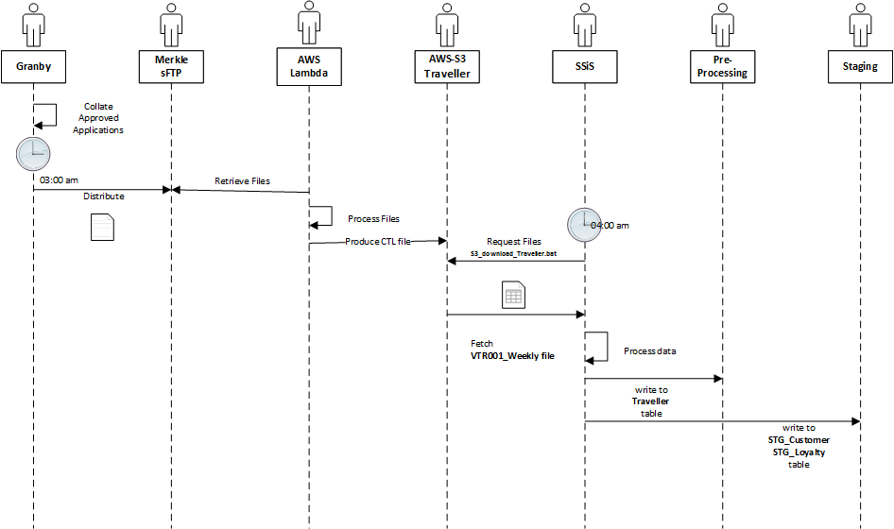

Each set of daily files will be loaded to pre-processing, and this document addresses the design of the load to the Staging environment from pre-processing.

## 3.2. Process Flow

The workflow will be invoked and the following logic applied…

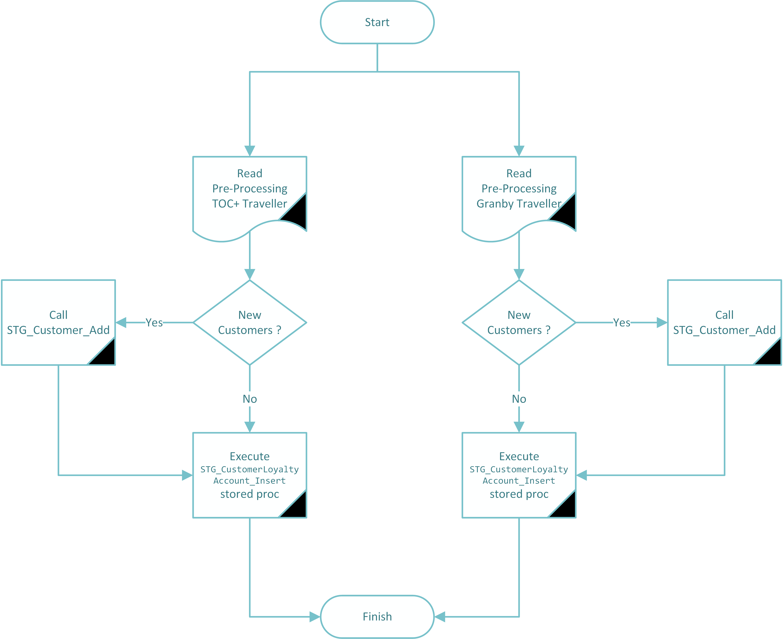

## 3.2 ERD

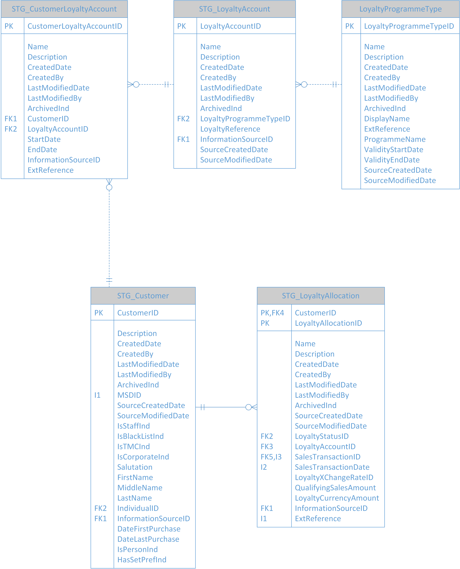

## 3.3 Mapping

STG_CustomerLoyaltyAllocation will be populated from the pre-processing [TOCPLUS_Traveller] and [Granby_Traveller] tables and inserted using the procedure Preprocessing.STG_CustomerLoyaltyAccount_Insert.

* The assumption is that the Customer load process will have run before this, and will have inserted any new customers provided in the two source feeds.
* Missing Customers could be added using the procedure [Staging].[STG_Customer_Add]

### Granby Traveller Feed

|  |  |  |  |  |  |  |  |  |  |  |
| --- | --- | --- | --- | --- | --- | --- | --- | --- | --- | --- |
| Source Table | Source Column | Source Data type | Primary Key | Column  Transformation  Rule | Comments/ Other Rules | Error Handling Rules | | Target Table | Target Column | Target Data type |
|  |  |  | Y |  | Identity Column | |  | STG_CustomerLoyaltyAllocation | CustomerLoyaltyAccountID | int |
|  |  |  |  |  | ** NOT USED ** | |  | STG_CustomerLoyaltyAllocation | Name | varchar |
|  |  |  |  |  | ** NOT USED ** | |  | STG_CustomerLoyaltyAllocation | Description | varchar |
|  |  |  |  |  | Current Date | |  | STG_CustomerLoyaltyAllocation | CreatedDate | Datetime |
|  |  |  |  | 0 | Default User | |  | STG_CustomerLoyaltyAllocation | CreatedBy | Int |
|  |  |  |  |  | Current Date | |  | STG_CustomerLoyaltyAllocation | LastModifiedDate | datetime |
|  |  |  |  | 0 | Default User | |  | STG_CustomerLoyaltyAllocation | LastModifiedBy | int |
|  |  |  |  | 0 | May be redundant if we apply the new archiving scheme | |  | STG_CustomerLoyaltyAllocation | ArchivedInd | bit |
| Granby_Traveller | CUID | bigint |  | CU_ID | Lookup from STG_KeyMapping returning CustomerID | |  | STG_CustomerLoyaltyAllocation | CustomerID | Int |
|  | loyalty_membership_num |  |  | Preprocessing.STG_CustomerLoyaltyAccount_Insert | Lookup populated by sp | |  | STG_CustomerLoyaltyAllocation | LoyaltyAccountID | int |
|  |  |  |  |  | Lookup for source for Granby Traveller | |  | STG_CustomerLoyaltyAllocation | InformationSourceID | int |
| Granby_Traveller | CreatedDateETL | datetime |  |  |  | |  | STG_CustomerLoyaltyAllocation | SourceCreatedDate | datetime |
| Granby_Traveller | LastModifiedDateETL | datetime |  |  |  | |  | STG_CustomerLoyaltyAllocation | SourceModifiedDate | datetime |
| Granby_Traveller | external_reference | nvarchar |  |  |  | |  | STG_CustomerLoyaltyAllocation | ExtReference | varchar |
| Granby_Traveller | eff_to_date | datetime |  | DATEADD(y, -1, eff_to_date) | Truncate to Date, calculate a year before End Date | |  | STG_CustomerLoyaltyAllocation | StartDate | date |
| Granby_Traveller | eff_to_date | datetime |  |  | Truncate to Date | |  | STG_CustomerLoyaltyAllocation | EndDate | Date |
|  |  |  |  | ‘A’ | ‘A’ = Active | |  | STG_CustomerLoyaltyAllocation | Status | char |

### TOCPlus Traveller Feed

|  |  |  |  |  |  |  |  |  |  |  |
| --- | --- | --- | --- | --- | --- | --- | --- | --- | --- | --- |
| Source Table | Source Column | Source Data type | Primary Key | Column  Transformation  Rule | Comments/ Other Rules | Error Handling Rules | | Target Table | Target Column | Target Data type |
|  |  |  | Y |  | Identity Column | |  | STG_CustomerLoyaltyAllocation | CustomerLoyaltyAccountID | int |
|  |  |  |  |  | ** NOT USED ** | |  | STG_CustomerLoyaltyAllocation | Name | varchar |
|  |  |  |  |  | ** NOT USED ** | |  | STG_CustomerLoyaltyAllocation | Description | varchar |
|  |  |  |  |  | Current Date | |  | STG_CustomerLoyaltyAllocation | CreatedDate | Datetime |
|  |  |  |  | 0 | Default User | |  | STG_CustomerLoyaltyAllocation | CreatedBy | Int |
|  |  |  |  |  | Current Date | |  | STG_CustomerLoyaltyAllocation | LastModifiedDate | datetime |
|  |  |  |  | 0 | Default User | |  | STG_CustomerLoyaltyAllocation | LastModifiedBy | int |
|  |  |  |  | 0 | May be redundant if we apply the new archiving scheme | |  | STG_CustomerLoyaltyAllocation | ArchivedInd | bit |
| TOCPLUS_Traveller | CU_ID | bigint |  | CU_ID | Lookup from STG_KeyMapping returning CustomerID | |  | STG_CustomerLoyaltyAllocation | CustomerID | Int |
|  | loyalty_membership_num |  |  | Preprocessing.STG_CustomerLoyaltyAccount_Insert | Lookup populated by sp | |  | STG_CustomerLoyaltyAllocation | LoyaltyAccountID | int |
|  |  |  |  |  | Lookup for source for TOCPLUS Traveller | |  | STG_CustomerLoyaltyAllocation | InformationSourceID | int |
| TOCPLUS_Traveller | CreatedDateETL | datetime |  |  |  | |  | STG_CustomerLoyaltyAllocation | SourceCreatedDate | datetime |
| TOCPLUS_Traveller | LastModifiedDateETL | datetime |  |  |  | |  | STG_CustomerLoyaltyAllocation | SourceModifiedDate | datetime |
| TOCPLUS_Traveller | loyalty_membership_num | nvarchar |  |  |  | |  | STG_CustomerLoyaltyAllocation | ExtReference | varchar |
| TOCPLUS_Traveller | eff_from_date | datetime |  |  | Truncate to Date | |  | STG_CustomerLoyaltyAllocation | StartDate | date |
| TOCPLUS_Traveller | eff_to_date | datetime |  |  | Truncate to Date | |  | STG_CustomerLoyaltyAllocation | EndDate | Date |
| TOCPLUS_Traveller | Status | nchar |  |  | ‘A’ = Active | |  | STG_CustomerLoyaltyAllocation | Status | char |

3.4 Database Changes

### Reference Data

Traveller needs to be added to the reference table **LoyaltyProgrammeType** using the stored procedure [Reference].[LoyaltyProgrammeType_Set].

The following values should be populated when calling the stored procedure…

|  |  |
| --- | --- |
| Field | Value |
| Name | Traveller |
| DisplayName | Traveller |
| ProgrammeName | Traveller |
| ExtReference | Traveller,Granby Traveller,TOCPlus Traveller |
| ValidityStartDate** | 1997-03-09 |
| ValidityEndDate | 2099-12-12 |

* The Validity Start Date has been set to the franchise start date for Virgin Trains.

### Structure

**STG_CustomerLoyaltyAccount** needs to be extended to store **status** char(1) defaulting to ‘A’ for active.

### Stored Procedures

[Reference].[LoyaltyProgrammeType_Set] needs to be extended to allow StartDate, EndDate and Status to be passed as parameters.

[Preprocessing].[STG_CustomerLoyaltyAccount_Insert] needs to be extended to process the correct pre-processing table based upon a new parameter InformartionSourceID passed in. Valid Information Sources would be Traveller or TOCPlus.

**END**